

**The Hashemite University, Zarqa, Jordan**

**Faculty of Prince Al-Hussein Bin Abdallah II For Information Technology**

**Software Engineering Department**

**Sustainable System**

**A project submitted**

**in partial fulfillment of the requirements for the**

**B.Sc. Degree in Software Engineering**

**By**

Osama Mohammad Khalil Ghnaim (2031722)

**Supervised by**

Dr. Mohammad Ibrahim Ahmad Zarour

**Committee Member Names**

First

**Month Year**

**9-2024 / 3-2025**

# CERTIFICATE

It is hereby certified that the project titled <***Sustainable System***>, submitted by undersigned, in partial fulfillment of the award of the degree of “Bachelor in Software Engineering” embodies original work done by them under my supervision.

All the analysis, design and system development have been accomplished by the undersigned. Moreover, this project has not been submitted to any other college or university.

***Osama Ghnaim*** (+962 795932908)

**Osama Ghnaim**

# ABSTRACT

One of the common problems for the Hotels owners/managers is the Utilization of water usage by guests, since the water consumption rate is unlimited for each client of the Hotels, many of the clients consume water in an Excessive way; which will impact the hotels in high water fees and also the country which include these hotels which will also lead to violate the concept of water sustainability.

The methodology I followed to solve this problem is to build a system that monitors the water usage by hour for each guest and then apply a certain discount in the room booking price for those who consumed the water under a predetermined rate, which will encourage guests decrease their usage of water.

Figure - Average water usage by hotels guests in each region

# ACKNOWLEDGEMENTS

Also, I would like to thanks a lot my supervisor: Dr. Mohammad Zarour and the head of Software Engineering: Dr. Bashar Al-Shboul for their instructions that were very helpful to accomplish this project in a correct and efficient manner.

# TABLE OF CONTENTS

CERTIFICATE II

ABSTRACT III

ACKNOWLEDGEMENTS IV

TABLE OF CONTENTS V

ABBREVIATIONS VII

LIST OF FIGURES VIII

LIST OF Tables IX

Chapter 1: Introduction 1

1.1 Overview 1

1.2 Project Motivation 1

1.3 Problem Statement 1

1.4 Project Aim and Objectives 1

1.5 Project Scope 2

1.6 Project Software and Hardware Requirements 2

1.7 Project Limitations 2

1.8 Project Expected Output 2

1.9 Project Schedule 2

1.10 Project, product, and schedule risks 2

1.11 Report Organization 2

Chapter 2: Literature Review 4

2.1 Introduction 4

2.2 Existing Systems 4

2.3 Overall Problems of Existing Systems 4

2.4 Overall Solution Approach 4

Chapter 3: Requirement Engineering and Analysis 5

3.1 Stakeholders 5

3.2 Use Case Diagram 5

3.3 Non-Functional User Requirements 5

3.3 Constraints 6

Chapter 4: Architecture and Design 7

4.1 Overview 7

4.2 Software Architecture 7

4.3 Software design 7

4.4 User interface design (prototype) 8

Chapter 5: Implementation Plan 9

5.1 Description of Implementation 9

5.2 Programming language and technology 9

5.3 part of implementation if possible 9

Chapter 6: Testing Plan 11

6.1 Black-box 11

6.2 White-box 11

6.3 Testing automation 11

Chapter 7: Conclusion and Results 12

7.1 Summary of accomplished project 12

7.2 Future Work 12

References 13

# ABBREVIATIONS

* **Water-scarcity**: Water scarcity is described as a condition where water demand exceeds over available water supply. A country or a region faces “water scarcity” when the availability of natural hygienic water falls below 1000 m3 per person per year (Pereira et al., 2002; Dehghani et al., 2019).
* **GUI**: A graphical user interface, or GUI, is a form of user interface that allows users to interact with electronic devices through graphical icons and visual indicators such as secondary notation.
* **IoT device**: IoT devices are pieces of hardware, such as sensors, actuators, gadgets, appliances, or machines, that are programmed for certain applications and can transmit data over the internet or other networks.
* **API**: stands for Application Programming Interface. In the context of APIs, the word Application refers to any software with a distinct function. Interface can be thought of as a contract of service between two applications. This contract defines how the two communicate with each other using requests and responses.
* **SDLC**: The software development lifecycle (SDLC) is the cost-effective and time-efficient process that development teams use to design and build high-quality software. The goal of SDLC is to minimize project risks through forward planning so that software meets customer expectations during production and beyond.
* **WLD**: stands for Water Level of Discount, used in “Sustainable system “ which refers to water limit that hotel guest must not exceed to get a discount in his total booking price.
* **NTP**: Network Time Protocol is a networking protocol for clock synchronization between computer systems over packet-switched, variable-latency data networks.

# LIST OF FIGURES

* Figure - Average water usage by hotels guests in each region
* Figure 2:-Stakeholders breakdown via *Sustainable system*
* Figure 3:- Use Case diagram main scenario via *Sustainable System*
* Figure 4:- Use Case diagram alternative scenario via *Sustainable System*
* Figure 5:- Conceptual class diagram via *Sustainable System*
* Figure 6:- Sequence diagram via *Sustainable System*
* Figure 7:- Deployment diagram via *Sustainable System*
* Figure 8 :- Sequence diagram for each use-case via *Sustainable System*
* Figure 9 :- Specification class diagram via *Sustainable System*
* Figure 10 :- ER diagram via *Sustainable System*
* Figure 11 :- Web page GUI via *Sustainable System*
* Figure : The guest deserves the discount via *Sustainable System*
* Figure 13 :- Guest water usage data via *Sustainable System*
* Figure 14:- a peace of Web App code via *Sustainable System*
* Figure 15:- peace of Node JS code for IoT Specific via *Sustainable System*
* Figure 16:- peace of Node js code for Backend API via *Sustainable System*

# LIST OF Tables

* Table 1:- Use case illustrative table via *Sustainable system*
* **Table 2:- sample of Database tables via *Sustainable System***

# Introduction

In this chapter I will document the general view of this project and conduct the bases for the ideas it includes.

## Overview

Basically, “Sustainable system” project considered a water saving technology which encourage hotel guests to save water by monitoring their usage and decreasing their checkout price based on the decreasing level of water they applied.

## Project Motivation

The main reasons that prompted me to create “Sustainable system” project are how simple this project is and the range it will positively impact the sustainability of water around the world, which is very important mainly in these regions that suffer from water-scarcity. The new techniques I introduced in this project are used properly for this purpose.

## Problem Statement

Water is a vital and limited resource, and its efficient use is crucial for sustainability. However, many hotels worldwide continue to waste significant amounts of water through inefficient practices and infrastructure. This excessive water consumption is contributing to environmental degradation, increasing operational costs, and straining local water supplies. Despite the growing awareness of sustainability in the hospitality industry, many hotels still lack proper water management systems, awareness programs, and incentives to reduce water wastage.

The problem is multifaceted, involving areas such as excessive water use in guest rooms (e.g., showers, baths, and toilets), inefficient laundry operations, and over-irrigation of landscaping. In addition, the lack of proper monitoring, leak detection systems, and the absence of water-saving technologies further exacerbates the issue.

This water wastage not only impacts the hotel’s bottom line but also has long-term environmental and social consequences, including the depletion of local water resources, increased energy consumption, and a negative impact on the hotel's brand image. There is an urgent need for hotels to adopt comprehensive water management strategies to reduce wastage, implement water-efficient technologies, and raise awareness among both staff and guests about the importance of conservation. Addressing this issue will help conserve water, lower operational costs, and contribute to the hotel’s commitment to environmental sustainability.

The “Sustainable system” project is intended water conservation in hotels, also to save money on both guests and hotel owners, which is achieved through a collaboration of hardware and software elements.

## Project Aim and Objectives

The “Sustainable system” project aim to reduce the wasting of water in hotels by building a system that contains software and hardware elements, these elements will monitor and document hotel clients usage of water by hour and apply a certain discount if the clients consumes water under a predetermined limit (defined by the hotel owner/manager), the project will also provide a GUI dashboard that explains water consumption rate for each clients.

## Project Scope

“Sustainable system” is implemented specifically for hotel sectors, as I said before the project concerns limitation of water usage by hotel clients.

The system is based on a relational database that will record the client’s usage of water by hour and based on their total use, the system determines if the client deserves a discount on his checkout price or not.

## Project Software and Hardware Requirements

1. IoT device with a sensor to calculate water usage per hour.
2. API that takes data from IoT device and sends them properly to a Database.
3. Data base that records water usage for clients based on room number and time.
4. Discounter (web page) that shows water usage to clients in a simple and attractive way using GUI dashboard.

## Project Limitations

The system components include the API middleware that connects IoT device with the database, the database and the discounter web application that represents the visual and interactive part of the project, while the IoT device in a whole will be out of the implementation scope of this project.

## Project Expected Output

The final product must be a system that calculates a discount price for hotel clients who conserve water drain.

## Project Schedule

From ‘10/2/2025’ to ‘13/3/2025’ : Requirements, Specification and Analysis.

From ‘14/3/2025’ to ‘30/3/2025’ : Logical and physical design.

From ‘31/3/2025’ to ‘6/4/2025’ : Database conducting .

From ‘7/4/2025’ to ‘20/4/2025’ : Backend Development.

From ’20/4/2025’ to ‘10/5/2025’ : Frontend Development.

From ‘11/5/2025’ to ‘25/5/2025’ : Validation , Verification and Testing.

## Project, product, and schedule risks

***Project :***

Sustainable System for water in Hotels.

***Products :***

1. SRS document.
2. Design Document.
3. Data base initiation.
4. Backend API.
5. IoT device Simulation code.
6. Frontend API.
7. Web Application.

***Risks :***

1. Operating the Database on the hardware.
2. Simulating the IoT Device functions.

## Report Organization

The report I created is organized as follows:

Chapter 1:

Introduction: includes a comprehensive overview about the “Sustainable system” project in a whole, therefore it contains a complete information about the value of this project, the problem it addresses, in addition to the system configuration and the requirements needed to operate this system.

Chapter 2:

Literature review: contains the topic that my project deals with which is applied in a subjective way, besides mentioning researches that interested in water wasting problem and the efforts that attempts to solve it among the world.

Chapter 3:

Requirement Engineering and Analysis: represents the first phase of SDLC, where the software project is established and the actual outcomes are inhand.

Chapter 4:

Architecture and Design: Representing the second phase of the SDLC, the program is developed to be a breakdown of several views and diagrams that explain the work to be carried out in a unified manner based on certain methodologies.

# Literature Review

Water conservation is an increasingly important aspect of sustainable development, especially in industries with high water consumption, such as hospitality. Hotels, which typically operate many rooms, are significant water consumers. The development and implementation of water conservation systems in hotels have thus become a priority to reduce environmental impact and operational costs. This review explores various studies and initiatives related to water-saving systems and practices in the hotel industry, highlighting key strategies, technologies, and outcomes.

## Introduction

Water is one of the most essential resources for hotel operations. It is used in guest rooms, kitchens, bathrooms, pools, and landscaping. According to a study by *Hana Namrouqa (2012) in Jordan*, A water audit of 19 hotels in Jordan revealed average water consumption rates as follows: Two- and three-star hotels: consumes 160 liters per guest per day, Four-star hotels: consumes 349 liters per guest per day while Five-star hotels: consumes 873 liters per guest per day, Hotels in Aqaba consume 35% of the water supplied by the Aqaba Water Company.

This study underscores the significant water usage in hotels, especially in regions like the Middle East where water scarcity is a pressing concern. Implementing conservation measures can lead to substantial reductions in water consumption, alleviating pressure on local water resources.

## Existing Systems

Several technologies have been developed to reduce water consumption in hotels. One significant advancement is the installation of low-flow fixtures, such as showerheads, faucets, and toilets, which can drastically reduce water usage without compromising guest experience.

A notable case study demonstrating significant water savings through the implementation of low-flow fixtures in hotels is the Holiday Inn San Antonio International Airport. In 2007, this hotel participated in the San Antonio Water System's (SAWS) WaterSaver Hotel Program, which provided incentives for retrofitting bathroom fixtures. By replacing outdated toilets, faucets, and showerheads in its 397 guest rooms with high-efficiency models, the hotel achieved a 35% reduction in water usage, saving approximately 7 million gallons annually. This initiative also led to substantial energy savings, reducing consumption by 330,000 kWh per year, and resulted in combined annual savings of about $68,000 in water, sewer, and energy costs*.*

Another study titled *"Hong Kong Hotels' Sewage: Environmental Cost and Saving Technique"* by Chan, W.W., Wong, K., and Lo, J. (2009) investigates the environmental costs associated with sewage from Hong Kong hotels and explores techniques for cost savings, particularly focusing on water conservation methods.

*Key Findings of the study:*

* **Water Consumption Trends**: The average water consumption per occupied room decreased from 1.145 m³ in 1994–1996 to 0.904 m³ in 2001–2002, indicating improved water efficiency in the hotel industry.
* **Environmental Costs**: The environmental cost of sewage discharged by hotels was estimated at over HK$187 million in 2005 and exceeded HK$364 million by 2008, reflecting the significant financial impact of wastewater management.
* **Water-Saving Devices**: Flow regulators and submeters were identified as the two most commonly used water-saving devices in local hotels, contributing to reduced water consumption.

While also technologies play a key role in water conservation, operational and behavioral strategies are also crucial for minimizing water consumption. One example is the study by Goldstein, Cialdini, and Griskevicius (2008) which examined how different messages influenced hotel guests' towel reuse behavior. They found that guests were more likely to reuse towels when informed that the majority of previous guests had done so, demonstrating the power of social norms in promoting environmentally friendly behavior.

*Key Findings of the study:*

* **Effectiveness of Social Norms**: The study found that messages incorporating descriptive social norms were more effective in encouraging towel reuse than those solely focusing on environmental reasons.
* **Specificity Enhances Impact**: Messages that specified the behavior of guests in the same room (e.g., "75% of guests who stayed in this room reused their towels") led to even higher compliance rates, suggesting that the perceived similarity or connection enhances the persuasive power of the message.

## Overall Problems of Existing Systems

Challenges and Future Directions :-

1. *Cost issues:*

Despite the benefits, the implementation of water conservation systems in hotels is often met with challenges. Lee and Kwon (2014) note that upfront costs for water-efficient technologies and systems can be a barrier for smaller or budget-conscious hotels. While the return on investment (ROI) for such systems is typically realized over time through reduced water bills, the initial expenditure can deter hotel owners.

B. *Technical and Maintenance Issues:*

The complexity of some systems presents challenges in terms of maintenance, technical expertise, and long-term viability. Research into simplifying designs and improving system longevity is needed for these technologies to become more mainstream.

C. *Guests Satisfaction issues:*

Additionally, there may be resistance to adopting water-saving measures due to concerns about guest satisfaction. For instance, low-flow fixtures might be perceived as less comfortable or effective, and guests may resist towel reuse programs, and other programs Aswell.

## Overall Solution Approach

In conclusion, water conservation systems in hotels are considered as a solution for addressing both environmental concerns and operational costs. While the adoption of water-efficient technologies, behavioral strategies, and policies have demonstrated positive outcomes, challenges related to cost, guest satisfaction, and implementation remain. Future developments in technology and greater regulatory support are expected to further enhance water conservation efforts in the hotel industry. As the demand for sustainable practices grows, hotels must continue to innovate and implement comprehensive water-saving strategies to ensure long-term sustainability.

Therefore, I build this sustainable system to save on both sides (guests and hotels) in a simple and low-priced way.

# Requirement Engineering and Analysis

## Stakeholders

**1-*Primery stakeholders:***

* Hotel Management:

Responsible for decision-making, resource allocation, implementing policies, budget allocation for water-saving technologies and determines the water rate value that activate the discount.

* Guests:

Play a key role in water conservation. Their awareness and behavior can influence water consumption. Hotels often engage guests through messaging and encourage them to use a discount if they conserve water.

* Booking staff:

The employee who inserts guests booking duration and applies the discount value on the total booking price (if there is a discount) and he is also responsible for viewing the water consumption on a visual dashboard for the guests on demand.

**2- *Secondary stakeholders:***

* **Hotel ownership:**

**Certainly, hotel owners are positively affected by this project by increasing their financial returns from this investment over time.**

* **Region and country:**

**Water sustainability considered an important aspect that prompted me to create this system.**

Figure 2:-Stakeholders breakdown via *Sustainable system*

## Use Case Diagram

* + 1. Use Case Section

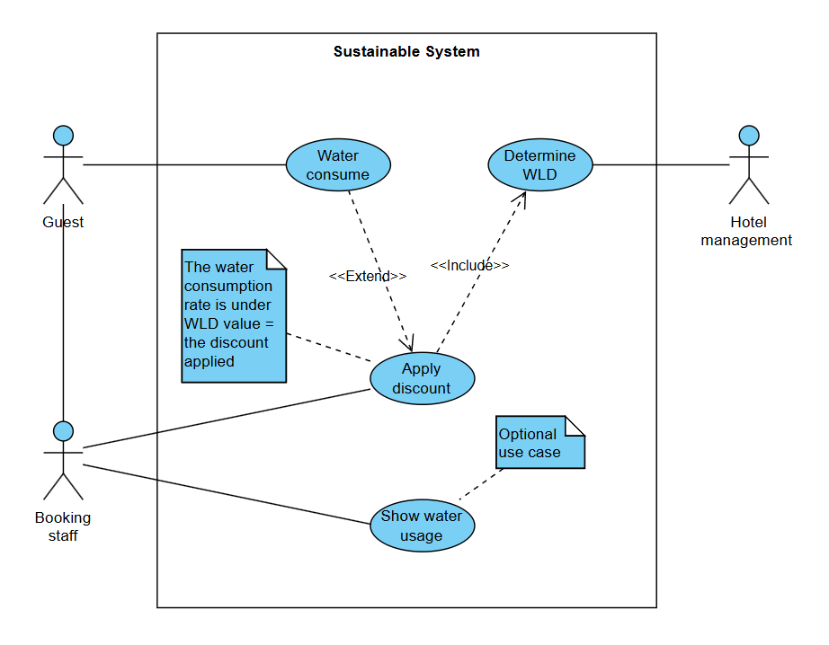

Figure 3:- Use Case diagram main scenario via *Sustainable System*

* + 1. Alternative flows

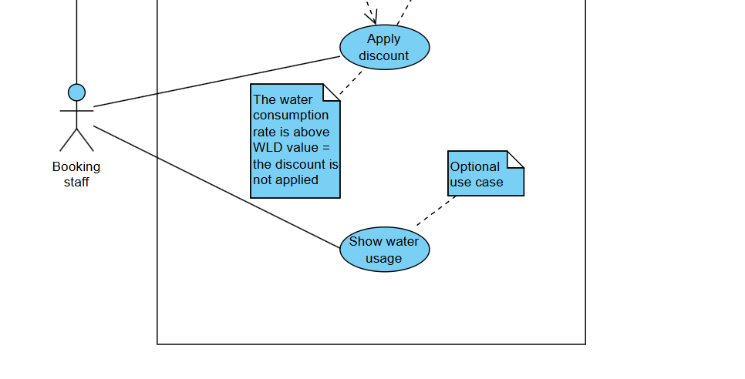

Figure 4:- Use Case diagram alternative scenario via *Sustainable System*

Table 1:- Use case illustrative table via *Sustainable system*

|  |  |  |  |  |  |  |  |  |
| --- | --- | --- | --- | --- | --- | --- | --- | --- |
| Number | Name | Priority | Actors | Precondition | Main scenario | Alternative scenario | Postcondition | Related use case |
| 1 | Determine WLD | High | Hotel management | Study the hotel’s water consumption and the appropriate hourly consumption limit | Hotel management determines WLD, and inserted it into the system | Null | Null | Apply discount |
| 2 | Water consume | High | Guest | The guest has booked into the hotel | Guest consumes water and IoT device sends water usage to API | Null | Null | Apply discount |
| 3 | Apply discount | Medium | Booking staff and Guest | The guest has finished reservation | Guest water usage is under the WLD | Guest water usage is above the WLD | The discount is applied, the discount isn’t applied | Water consume |
| 4 | Show water usage | Low | Guest and Booking staff | The guest Demand his water usage graph | Booking staff view water usage graph to the guest | The guest does not want to watch his water usage graph | Null | Null |

## 3.3 Non-Functional User Requirements

***1 – Execution qualities:***

* Useability: considered an important aspect of building this system, since the system has a simple orientation and a GUI web page that views the status happening clearly.
* Availability: another important aspect of this project because the guests must be able to finish his hotel booking any time he wants.
* Observability: the water usage graph on the GUI web page can show the data for booking staff and guests in a simple and clear manner.

***2- Evolution qualities:***

* Scalability: the system must be scalable due to the variation of room numbers in hotels and daily bookers.
* Reliability: due to the financial incomes and outcomes of this project beside the environmental impact, the reliability is a key for they system success.
* Maintainability: system splits into modules of software and hardware elements and the clarity of implementation will simplify maintenance efforts for the system.

## Constraints

***1 - Time:***

Time accuracy is considered a critical issue in this system operation; therefore, the API is developed to capture IoT device data every hour based on the timing in the installation region, which is implemented by using the NTP protocol.

***2 – Network:***

Network availability and performance which also plays a role in the system consistency and sustainability.

# Architecture and Design

## Overview

In this section I will be explaining the Sustainable System project in detail, a graphical representations that will make I easy to understand the system in a whole with all of its components and aspects.

## Software Architecture

* + 1. Logical view

*

Figure 5:- Conceptual class diagram via *Sustainable System*

* + 1. Process view

*Sustainable System* 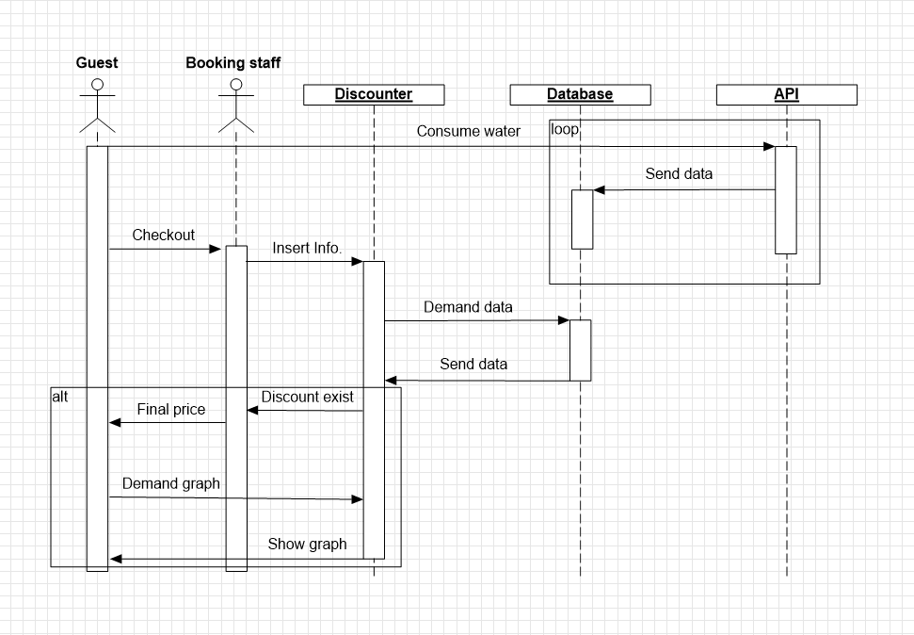

Figure 6:- Sequence diagram via *Sustainable System*

* + 1. Physical view

*

Figure 7:- Deployment diagram via *Sustainable System*

* + 1. Details of each component in a separate section.
* **IoT Device:** a device with an embedded software, that has a sensors in each in each room’s main water line, the sensors capture the water consumption rate and send it every hour to the Frontend API using HTTP post.
* **API Server:** a server device that has two API applications with HTTP post listeners in 2 ports of it (3000/2000) , the API act as a middleware for each two components of this system.
* **DB Server:** a Database server that stores the data that it receive from the Backend API and fetches it in a form when the Frontend API demands.
* **Web Server:** a server device (could be the Booking staff PC) that render the Web page and executing its code.

## Software design`

* + 1. UML sequence/communication diagram

*

Figure 8 :- Sequence diagram for each use-case via *Sustainable System*

* + 1. Class diagram

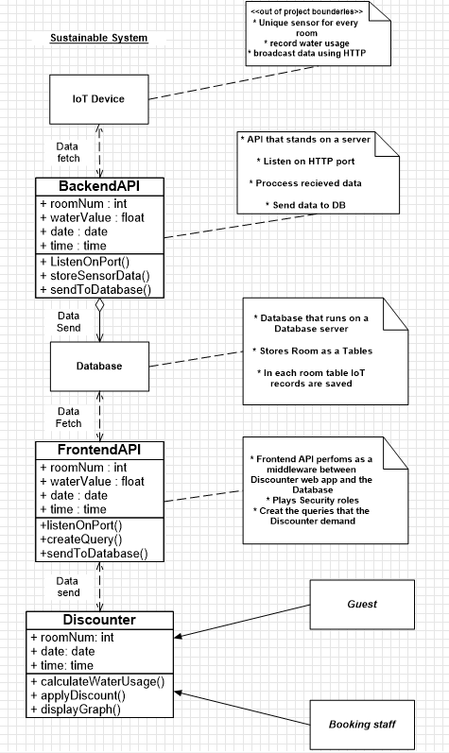

Figure 9 :- Specification class diagram via *Sustainable System*

* + 1. ER diagram

*

Figure 10 :- ER diagram via *Sustainable System*

## User interface design (prototype)

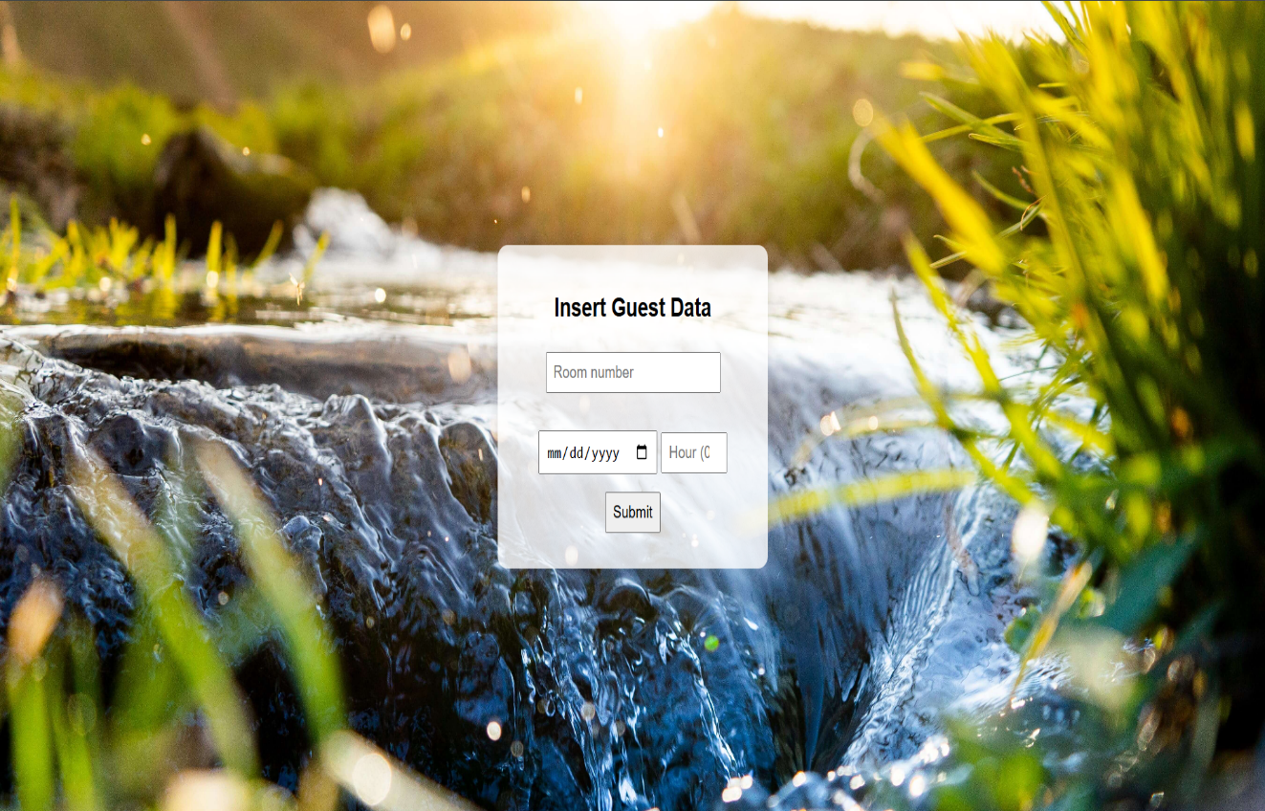

Figure 11 :- Web page GUI via *Sustainable System*

*

Figure 12 : The guest deserves the discount via *Sustainable System*

*

Figure 13 :- Guest water usage data via *Sustainable System*

# Implementation Plan

## Description of Implementation

So, basically this system will solve or try to solve the problem of water wastage in hotels by encouraging guests to be more conserve on their water usage. The major components and the required resources that are needed to accomplish this system are as follows:

* **Server:** a supercomputer that must be connected to the internet 24/7 and processing two applications at the same time (Frontend/Backend API’s) by operating every app on a different port 3000/2000 as an example.
* **Database Server:** a server that will obtain the database which will store guests data, and it must be connected to both API’s to be ready to receive there queries.
* **Computer:** mostly is the hotel reserve staff computer that is needed to operate the Web page which is the interface of this system that shows guests their water consumption rates and their discount claiming.

## Programming language and technology

Here is the applications I developed and the programming languages and technologies I used to implement them:

1. ***Web App:*** in the web application I used a combination of CSS, HTML and JavaScript code:

* **fetch():** is a modern JavaScript API that allows making HTTP requests asynchronously, It is considered the replacement for XMLHttpRequest and is commonly used for AJAX operations**.**
* **showPopup(message, isSuccess):** a function that is responsible for showing the discount claiming for the guest, it shows a green color if claimed and a red color otherwise with a claiming message.
* **displayGraph(data):** the function that shows the water usage graph for guests, there total consumption rate in liters and the average of their water usage per hour.

***2- API( Frontend/Backend ):*** a Node js server application that works as a middleware between the web app and the database, uses a variant node js modules:

* **http:** to create and manage HTTP servers and clients, and to handle its incoming http requests and responses.
* **odbc:** to interact with databases using ODBC (Open Database Connectivity).
* **cors:** (Cross-Origin Resource Sharing) t's used in Express applications to allow front-end applications to access the backend API from different domains.
* **express:** is a popular web framework for Node.js that simplifies routing, middleware management, and handling HTTP requests.
* **body-parser:** used in Backend API, It extracts the body of incoming HTTP requests and handles JSON, URL-encoded, or raw request payloads.

1. ***IoT( Random/Specific):*** a Node js applications that are used provide the Backend API with a dummy data to test the system performance, uses:

* **child-process:** to create and manage subprocesses (child processes) to execute system commands, scripts, or other Node.js programs.
* **exec():** Run shell commands, get output as a string.

1. ***SSMS Database :*** (SQL Server Management Studio), a free database server provider by Microsoft, which store the data and runs the SQL queries from both Frontend and Backend API’s, has ODBC Driver 17.

## part of implementation if possible

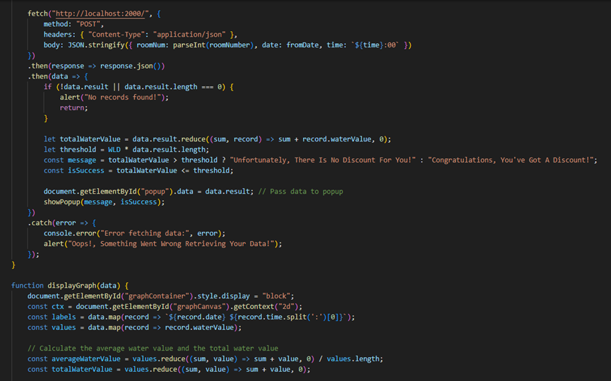

Figure 14:- a peace of JS code of the Web App via *Sustainable System*

Figure 15:- peace of Node js code for IoT Specific via *Sustainable System*

Figure 16:- peace of Node js code for Backend API via *Sustainable System*

**Table 2:- sample of Database tables via *Sustainable System***

# Testing Plan

Testing is one of the most important issues that I was interested in building this project, therefore I build an embedded applications that aims for testing the system, also I made a peace of codes for validation and verification methods and functions in this system.

## Black-box

Black-box testing in this system represented in both IoT modules that simulate IoT device actions, these modules generates a dummy data that represents the values of room number ,water consumption rate per hour ,date and time, and after generate this data randomly or specifically it send them to the Backend API using curl command and http post requests.

## White-box

White-box testing in this project has been applied by an integration and regression testing.

By developing a virtual IoT system that performs as an actual IoT device, the virtual IoT send a dummy data to the backend API and these data are rationally simulate the actual data and could be manipulated in much ways to ensure that the whole project system is working as it should.

## Testing automation

Regarding Testing automation IoT modules applications could play this role beside them being a type of White -box testing, testing automation actually very limited in this project according the nature of this project and the simplicity of its behavior .

# Conclusion and Results

In the end this project was intended to find a solution or a sub solution for water wastage in hotels, since hotels guests have no limitation for water rates and no responsibility allow them to conserve in water, a lot of researches has been done regarding this topic:

SEATTLE.GOV

In some cases, a hotel can use an average of 1,500 liters (approximately 396 gallons) per room per day, which can vastly exceed that of local populations in water-scarce destinations.

SUSTAINABLE HOSPITALITY ALLIANCE

The largest uses of water in hotels and lodging facilities are restrooms, laundry operations, landscaping, commercial kitchens, and heating and cooling.

## Summary of accomplished project

This project accomplished using hardware and software components that monitoring, manipulating, storing and showing data to the end users, these data helps user to a further vision of his attitudes with water usage in hotels, helps hotels fields to conserve in water and help the region/country in a whole to be water sustainable.

## Future Work

A lot of ideas could be implemented regarding the idea of this project and many other ways could be found to sustain water and other vital resources, such as electricity and natural gas.

As an example, for the countries that use gas pipelines to provide citizens with natural gas, a similar idea of this project could be accomplished by the government to conserve gas by monitoring gas consumption and similarly for electricity and so on.

# References

* Researches and articles in water conservations and in hotel fields specifically.
* Artificial intelligence such as ChatGPT and Copilot helps a lot to accomplish this project.
* Domain and area problems, in scarcity of natural resources.
* Religion, Islam approach in water conservation and not wasting it.
* U.S. Environmental Protection Agency. (2013). *WaterSense Current: Winter 2013*. Retrieved from <https://19january2017snapshot.epa.gov/www3/watersense/our_water/winter2013.html>
* Chan, W.W., Wong, K., & Lo, J. (2009). Hong Kong Hotels' Sewage: Environmental Cost and Saving Technique. *Journal of Hospitality & Tourism Research*, 33(3), 329–346.
* Goldstein, N. J., Cialdini, R. B., & Griskevicius, V. (2008). *A Room with a Viewpoint: Using Social Norms to Motivate Environmental Conservation in Hotels*. Journal of Consumer Research, 35(3), 472–482. <https://doi.org/10.1086/586910>
* *Hana Namrouqa. The Jordan Times . “Hotels Introduced to Water Conservation Practices”* (2012) . URL: <https://mideastenvironment.apps01.yorku.ca/2012/01/hotels-introduced-to-water-conservation-practices-jordan-times/>